Agenda

* Discuss Profit given.

|  |  |  |  |  |  |
| --- | --- | --- | --- | --- | --- |
| Client | Period | Profit Factor | % Per Month | Strategy | Capital (Lakh) |
| Client Id-Abhay | 1 Month | 5.21 | 13.93 | Short Credit Spread-EB | 3.25 |
| YWQ563 | 1Month | 6.23 | 20.05% | Short Credit Spread-EB | 7.98 |
| Mr Sanjay-US Market | 3 Month |  | 10.97% | BTST in small and Mid Cap | 12.85 |
| 5516 | 5 Month | >100 | 141% | Naked Option Buying | 0.25 |
| VWH918 | 15 Days |  | 19.92 | Short Credit Spread-EB | 10.0 |
| Lawyer | 1 Month |  | 5.15% | Hedge Option Buying | 10.0 |
| 5074 | 10 Days |  | 12.80% | Short Credit Spread-EB | 7.45 |

Abhay

Devender

Anuradha

5074

* Certification List

Government License Number by AMFI for Financial Advisory and Mutual Fund Operations: ARN-282569

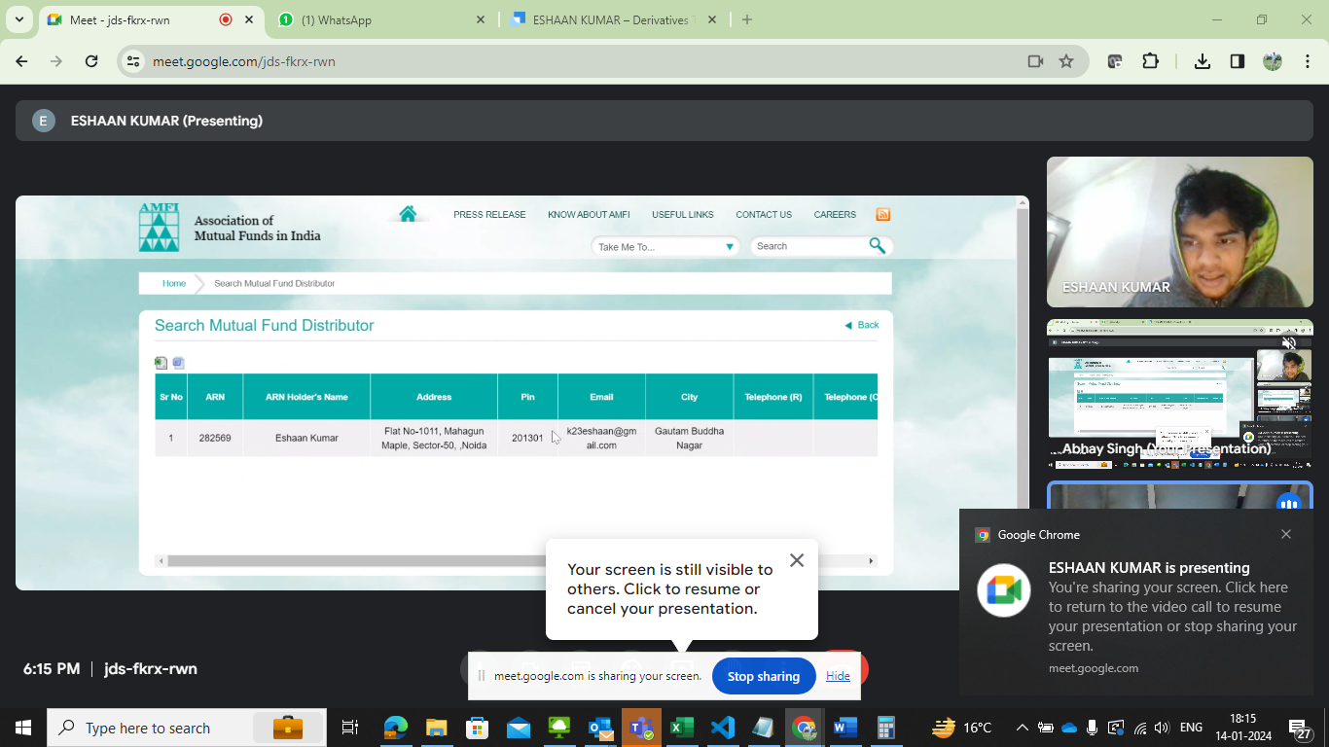

* PPT for 18th Jan
* Marketing Discussion

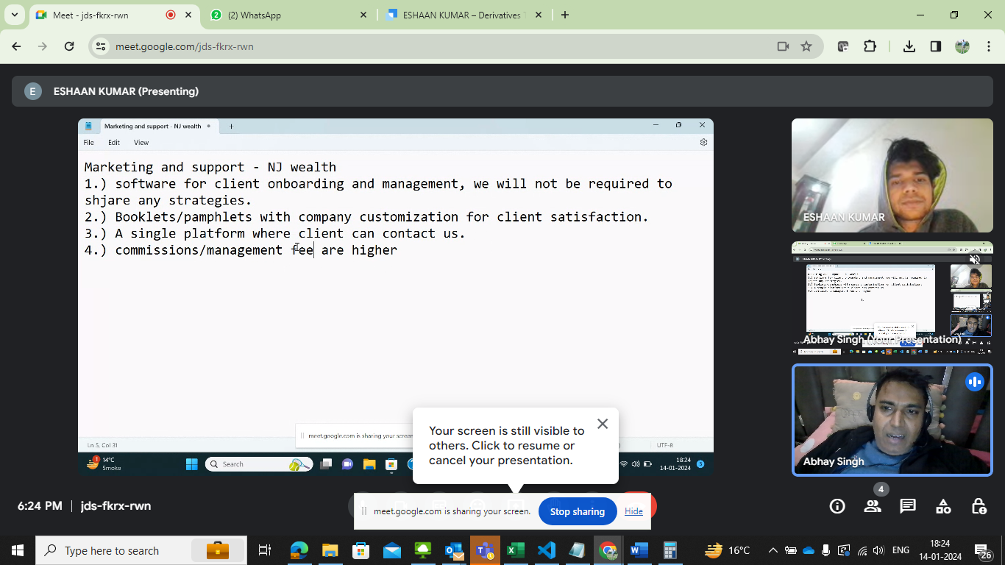

* Mode of operation
  + Fund Operation
  + Mutual Fund, Equity and our strategy
  + Compliance- Legal